Machine Learning-Based Insider Threat Detection System
A Capstone Project Report of MSIT 5910

Submitted by:
Savannah Ward
For the partial fulfilment of the requirements for the degree of
Master of Science in Information Technology

Supervised by: Dr. Shabia Shabir

Department of CS & MSIT
University of the People, Pasadena, CA 91101, United States
Term 4, April, 2026

ABSTRACT
Insider threats represent one of the most complex and persistent challenges in organizational cybersecurity. Unlike external attackers, insiders operate with legitimate credentials and permissions, making their malicious activity difficult to distinguish from normal user behavior using conventional signature-based security tools. This project proposes and implements a machine learning-based insider threat detection system that applies behavioral analytics to identify statistically anomalous users within a simulated organizational environment. The system uses the CERT 4.2 synthetic insider threat dataset developed by Carnegie Mellon University's Software Engineering Institute, which provides realistic simulations of login activity, file access, email communication, and USB device usage across 500 users over a 90-day period. The core detection mechanism is the Isolation Forest unsupervised anomaly detection algorithm, selected for its computational efficiency and its ability to identify outliers without requiring labeled training examples of malicious behavior. The system pipeline includes five sequential modules: data collection, preprocessing, feature engineering, anomaly detection, and risk scoring with visualization. Seventeen behavioral features are engineered per user, and anomaly scores are normalized to a 0 to 100 scale and classified into Low, Medium, and High risk tiers. Visualization outputs confirm that flagged users exhibit behavioral patterns consistent with known insider threat indicators, including elevated off-hours activity, high external email rates, and frequent USB connections. The findings demonstrate that unsupervised machine learning, when combined with domain-informed behavioral feature engineering and interpretable risk communication, provides an effective and practically deployable foundation for insider threat detection in environments where labeled incident data is unavailable.

ACKNOWLEDGEMENTS
I would like to express my sincere gratitude to my instructor for their continued guidance, constructive feedback, and support throughout the development of this project. Their expertise in the field of cybersecurity and machine learning has been invaluable in shaping both the direction and quality of this work.
I would also like to extend my appreciation to the Department Chair for fostering an academic environment that encourages rigorous research and practical application of technical knowledge. The structure and standards upheld by the department have been a constant source of motivation.
Finally, I am grateful to the University of the People for providing accessible, high-quality education and the resources necessary to undertake a project of this scope. The opportunity to engage with current challenges in cybersecurity through an applied research framework has been a truly rewarding academic experience.

LIST OF FIGURES
Figure 1: Top 20 Highest-Risk Users - Isolation Forest Risk Scores
Figure 2: Feature Correlation Heatmap -Correlation of Behavioural Features with Risk Score
Figure 3: Off-Hours Activity Rate - Normal vs Flagged Users
Figure 4: External Email Rate vs USB Connection Count -Coloured by Risk Score
Figure 5: System Architecture Diagram - Machine Learning-Based Insider Threat Detection System

LIST OF TABLES
Table 1: Summary of Engineered Behavioural Features
Table 2: Risk Level Classification Thresholds
Table 3: Functional Requirements Summary

CHAPTER 1: INTRODUCTION

1.1 Background of the Study
Cybersecurity is one of the fastest-growing disciplines in technology today, and organizations of all sizes face increasing pressure to protect their systems, data, and operational continuity. While public discourse around cybersecurity tends to focus on external attackers and sophisticated intrusion campaigns, one of the most difficult and persistently underestimated categories of threat originates from within organizations themselves. Insider threats, where employees, contractors, or authorized users misuse their access privileges, are challenging to detect because the individuals involved already possess legitimate credentials and permissions. This fundamental characteristic renders many conventional security controls, including perimeter firewalls, intrusion detection systems, and signature-based antivirus software, substantially less effective when the threat actor is already operating inside the trust boundary.
This project was inspired by a genuine interest in understanding how machine learning can be applied to address real-world cybersecurity problems that fall outside the reach of traditional security controls. During the initial literature review phase of this capstone, it became clear that most existing security systems rely on predefined rules and known attack patterns to generate alerts. The fundamental limitation of this approach is that insider behavior does not consistently resemble known attack signatures, especially in its early stages. A user who begins downloading files outside their normal access scope, or who repeatedly logs in during non-business hours, may not trigger any rule-based alerts even though these are behavioral warning signs that deserve investigation.
The application of machine learning to this problem offers a conceptually different solution. Rather than relying on fixed rules, a machine learning model can learn what normal behavioral patterns look like for the user population under study and then identify individuals whose behavior deviates statistically from that established baseline. This anomaly-based approach is especially well suited to insider threat detection because it does not require historical examples of confirmed malicious behavior to function. It learns normality and detects deviation, which is a fundamentally different and more robust detection strategy in environments where insider incidents are rare and difficult to label.
For this project, the CERT 4.2 synthetic insider threat dataset, developed by Carnegie Mellon University's Software Engineering Institute, was chosen as the primary data source. This dataset simulates realistic organizational behavior across login activity, file access, email communication, and workstation usage, providing a controlled and ethically appropriate environment in which to develop and evaluate a behavioral analytics pipeline. The Isolation Forest algorithm was selected as the core anomaly detection mechanism due to its proven effectiveness on high-dimensional, unlabeled data and its computational efficiency at scale.
The goal of this project was not merely to train a model but to design and implement a complete, end-to-end detection system that a working cybersecurity analyst could reasonably use and understand. This required deliberate attention to how model outputs were considered, ensuring that results are presented as interpretable risk scores with categorical classifications rather than numerical outputs. Through this project, a substantially deeper understanding of both machine learning and applied cybersecurity was developed, and the resulting system provides a strong foundation for continued research and practical application.

1.2 Problem Statement
Insider threats represent one of the most difficult challenges in cybersecurity because they originate from users who already have legitimate access to organizational systems. These users are not external attackers, which makes their malicious actions harder to detect using traditional security mechanisms that rely on perimeter defense and known threat signatures.
Conventional security systems depend heavily on predefined rules or known attack patterns. However, insider behavior often appears indistinguishable from normal activity in its early stages, making rule-based detection ineffective. This problem is further compounded by the significant class imbalance inherent in user activity data: malicious behavior is rare relative to the volume of routine, legitimate activity that security systems must process. Any detection model that cannot handle this imbalance will either generate excessive false positives that overwhelm analysts, or miss genuine threats by defaulting to the assumption of normality.
Organizations generate large volumes of user activity data across multiple systems including authentication servers, file storage platforms, email infrastructure, and endpoint management tools. While this data contains rich behavioral information that could support threat detection, it is frequently underutilized due to its volume, heterogeneity, and the complexity of integrating records across disparate source systems. Machine learning provides an opportunity to analyze this multi-source data at scale and surface patterns that indicate abnormal behavior before they escalate into confirmed incidents.
Insider threat detection presents several compounding technical challenges. The scarcity of labeled datasets reflecting confirmed malicious insider behavior makes supervised learning approaches impractical in most organizational environments. User behavior is also inherently dynamic and evolves over time, meaning that static models may become outdated as work patterns shift. There is therefore a need for an intelligent, adaptive system that can analyze multi-source user activity data, establish personalized behavioral baselines, and detect deviations in a manner that is both computationally feasible and interpretable for human security analysts.

1.3 Objectives of the Study
The primary objectives of this project are as follows:
• To design and implement a modular machine learning pipeline for insider threat detection using behavioral analytics drawn from multiple organizational data sources.
• To apply the Isolation Forest unsupervised anomaly detection algorithm to identify users exhibiting statistically deviant behavioral patterns without requiring labeled training data.
• To engineer seventeen meaningful behavioral features from raw user activity logs that capture login timing, file access patterns, email behavior, and device usage in a manner that is sensitive to insider threat indicators.
• To develop an interpretable risk scoring and visualization layer that presents model outputs as normalized, categorical risk classifications accessible to cybersecurity analysts with varying technical backgrounds.
• To evaluate system performance using the CERT 4.2 synthetic insider threat dataset and validate findings through behavioral comparison and visualization analysis.

1.4 Scope and Limitations
This project focuses on the design, implementation, and evaluation of a prototype insider threat detection system using the CERT 4.2 synthetic dataset. The system is designed as a batch processing pipeline rather than a real-time monitoring system, and operates on historical log data aggregated over a 90-day observation window. The scope includes all five pipeline stages: data collection, preprocessing, feature engineering, anomaly detection, risk scoring, and visualization.
Key limitations include the use of synthetic rather than real organizational data, which may not fully capture the behavioral complexity or environmental noise present in live deployments. The system relies on static feature aggregation over a fixed time window, which may not detect gradual behavioral drift that occurs across longer timeframes. The unsupervised nature of the Isolation Forest algorithm means that anomaly scores do not directly indicate confirmed malicious intent, and all flagged cases require human analyst review before any organizational response is initiated.

1.5 Report Organization
This report is structured as follows. Chapter 2 presents a comprehensive review of existing literature on insider threat detection and machine learning-based anomaly detection methods. Chapter 3 describes the system design, including the architecture, methodology, and data flow across all five pipeline modules. Chapter 4 presents the results of the implementation, including output visualizations and evaluation analysis. Chapter 5 discusses the findings in the context of existing literature and addresses limitations and ethical considerations. Chapter 6 documents milestones achieved and challenges encountered. Chapter 7 provides the conclusion and recommendations for future work.

CHAPTER 2: LITERATURE REVIEW

2.1 Overview of Related Work
Insider threat detection has emerged as a critical research priority in cybersecurity, driven by the increasing frequency and impact of internal security breaches across both public and private sector organizations. The challenge is distinct from external threat detection because the actors involved hold valid credentials and operate within sanctioned access boundaries, rendering conventional perimeter-based security controls insufficient. The academic literature reflects a clear trajectory away from rule-based detection approaches toward data-driven, behavioral analytics methods that can identify anomalous user activity without relying on predefined attack signatures.
Homoliak et al. (2020) propose a security reference architecture for insider threat detection that structures the detection problem around three core capabilities: behavioral monitoring, anomaly detection, and continuous risk assessment. Their architecture emphasizes that effective detection cannot rely on a single data modality and requires the integration of authentication records, file access logs, and communication metadata into a unified behavioral profile. The multi-source data collection design adopted in this project reflects the principles established by Homoliak et al., combining logon, file, email, and USB device data into a consolidated behavioral feature matrix.
The foundational algorithm employed in this project, Isolation Forest, was introduced by Liu et al. (2008) in a landmark paper demonstrating its superior performance relative to contemporary anomaly detection methods including one-class support vector machines and Local Outlier Factor across multiple benchmark datasets. Liu et al. established that the algorithm's core mechanism, isolating observations through recursive random pdartitioning, is computationally efficient with linear average time complexity and scales effectively to high-dimensional data. These properties make it particularly well suited to cybersecurity applications where event logs can span millions of records and feature spaces span dozens of behavioral dimensions.
Kotu and Deshpande (2020) address the foundational role of data preprocessing and feature engineering in machine learning pipelines, emphasizing that the quality and relevance of engineered features determine model performance more reliably than algorithm selection alone. In cybersecurity applications, raw log data records individual events without inherent behavioral context. Transforming these records into meaningful per-user behavioral indicators, such as off-hours activity rates, external communication frequency, and data transfer volumes, is a critical design step that bridges the gap between raw system data and interpretable anomaly detection.
Gavai et al. (2015) evaluated insider threat detection on the CERT dataset using both supervised and unsupervised approaches across multiple data modalities. Their central finding is that combining authentication, file access, and communication data produces substantially better detection performance than any single data source in isolation. This multi-modal integration result directly supports the data collection architecture of the present project, which consolidates four data sources into a unified behavioral feature matrix rather than treating each source independently.
Tuor et al. (2017) explored the application of recurrent neural networks to insider threat detection in streaming data environments, highlighting the importance of temporal modeling for capturing behavioral drift that evolves gradually over time. While this project adopts a static aggregation approach rather than a sequential model, the findings of Tuor et al. directly inform the limitation analysis presented in Chapter 5, where the inability to capture temporal behavioral evolution is identified as a meaningful constraint on the current system's detection capabilities.
Yuan and Wu (2021) examined the role of feature selection in anomaly detection for cybersecurity applications, demonstrating that domain-specific behavioral features, particularly those related to temporal access patterns and data exfiltration indicators, significantly improve model sensitivity relative to models trained on raw event counts. This finding supports the deliberate feature design adopted in this project, where features such as off-hours login rate and external email rate were engineered specifically because they correspond to documented behavioral signatures of insider threat activity.
Aggarwal (2021) provides a comprehensive theoretical treatment of anomaly detection methods, contextualizing Isolation Forest within the broader landscape of outlier detection algorithms. Aggarwal's analysis confirms that Isolation Forest is particularly effective in settings where anomalies are rare relative to the overall data volume, a characteristic that directly matches the insider threat detection context where confirmed malicious behavior represents a small fraction of total user activity.
The CERT 4.2 synthetic insider threat dataset, developed by the Software Engineering Institute at Carnegie Mellon University, has become the de facto standard benchmark for insider threat detection research due to its realistic simulation of organizational user behavior and its ethical design that avoids the privacy concerns associated with real user data (CERT Division, 2023). The dataset has been used in numerous peer-reviewed evaluations and provides a controlled, reproducible environment for assessing the behavioral discrimination capabilities of detection systems.
Patcha and Park (2007) provide a foundational overview of anomaly detection techniques in network security contexts, establishing the conceptual distinction between signature-based and anomaly-based detection that remains central to the field. Their survey demonstrates that anomaly detection is fundamentally better suited to detecting novel or evolving threats, a conclusion that generalizes directly to the insider threat detection domain where behavioral patterns are highly individualized and not easily captured by fixed signatures.

2.2 Comparative Analysis of Existing Systems
Existing insider threat detection systems can be broadly categorized into three approaches: rule-based systems, supervised learning systems, and unsupervised learning systems. Each approach presents distinct trade-offs between detection accuracy, interpretability, and practical deployability.
Rule-based systems operate on predefined behavioral thresholds and known attack signatures. These systems offer high precision for threat patterns that are well-characterized and stable, and they provide clear audit trails that explain why a specific alert was generated. However, they require continuous manual maintenance as organizational environments and attacker techniques evolve, and they are fundamentally incapable of detecting novel insider behaviors that fall outside the predefined rule set.
Supervised learning systems, including those based on support vector machines, random forests, and gradient boosting classifiers, can achieve high detection accuracy when labeled training data is available. Their practical applicability to insider threat detection is severely constrained by the scarcity of confirmed incident labels. Most organizations have few or no verified insider threat cases in their historical data, making it impossible to construct balanced training sets that adequately represent the malicious class. The models that result from training on highly imbalanced data tend to be biased toward predicting the majority class and fail to detect genuine anomalies.
Unsupervised learning systems, including isolation forest, autoencoders, clustering-based methods, and one-class support vector machines, address the labeled data problem by learning the statistical distribution of normal behavior and identifying deviations without requiring prior examples of malicious activity. These systems are substantially more practical for real-world deployment in organizations that lack labeled incident datasets. Their primary limitation is the potential for elevated false positive rates, as genuine but unusual normal behavior may resemble the statistical profile of an anomaly. Careful threshold calibration and human-in-the-loop review processes are essential to managing this limitation effectively.
The system designed in this project adopts an unsupervised approach based on Isolation Forest, prioritizing practical deployability over the theoretical detection accuracy achievable with labeled supervised methods. This decision reflects both the realities of the academic context in which the project was developed and the operational realities of most organizational environments where insider threat detection systems must function without access to reliable incident labels.

2.3 Research Gap Identification
While existing research has demonstrated the effectiveness of machine learning for insider threat detection, several meaningful gaps remain that motivate the design decisions made in this project. First, most published prototype implementations focus exclusively on model accuracy metrics without addressing the interpretability of outputs for non-specialist security analysts. A system that produces precise anomaly scores but presents them as raw numerical outputs provides limited operational value in environments where analysts must translate model outputs into actionable investigative priorities.
Second, many existing prototype systems rely on single-source behavioral data, evaluating logon records or file access logs in isolation. The multi-modal integration demonstrated by Gavai et al. (2015) to substantially improve detection performance is frequently absent from prototype implementations, likely due to the additional engineering complexity of consolidating heterogeneous data sources. The present project directly addresses this gap through its multi-source data collection architecture.
Third, the transition from academic prototype to operationally deployable system requires deliberate attention to risk communication design, human-in-the-loop decision support, and the ethical governance of user monitoring. These considerations are rarely addressed in technical papers focused on model performance. This project addresses these dimensions through its interpretable risk scoring layer, its tiered risk classification system, and the explicit ethical analysis presented in Chapter 5.

CHAPTER 3: SYSTEM DESIGN

3.1 System Architecture
The proposed system is a modular machine learning pipeline designed to detect insider threats based on statistical deviations in user behavioral profiles. The architecture consists of five core modules: Data Collection, Data Preprocessing, Feature Engineering, Anomaly Detection, and Risk Scoring with Visualization. These modules are designed to be independent and reusable, supporting scalability and future integration with real-time data streams. Walker (2022) identifies the pipeline architectural pattern as particularly well suited to data-intensive processing systems where each stage has clearly defined inputs and outputs, making it an appropriate choice for a multi-stage behavioral analytics system. Each module produces a well-defined output that serves as the direct input to the subsequent stage, ensuring consistency and traceability throughout the pipeline, a design principle that Summers (2020) describes as central to successful systems engineering frameworks.
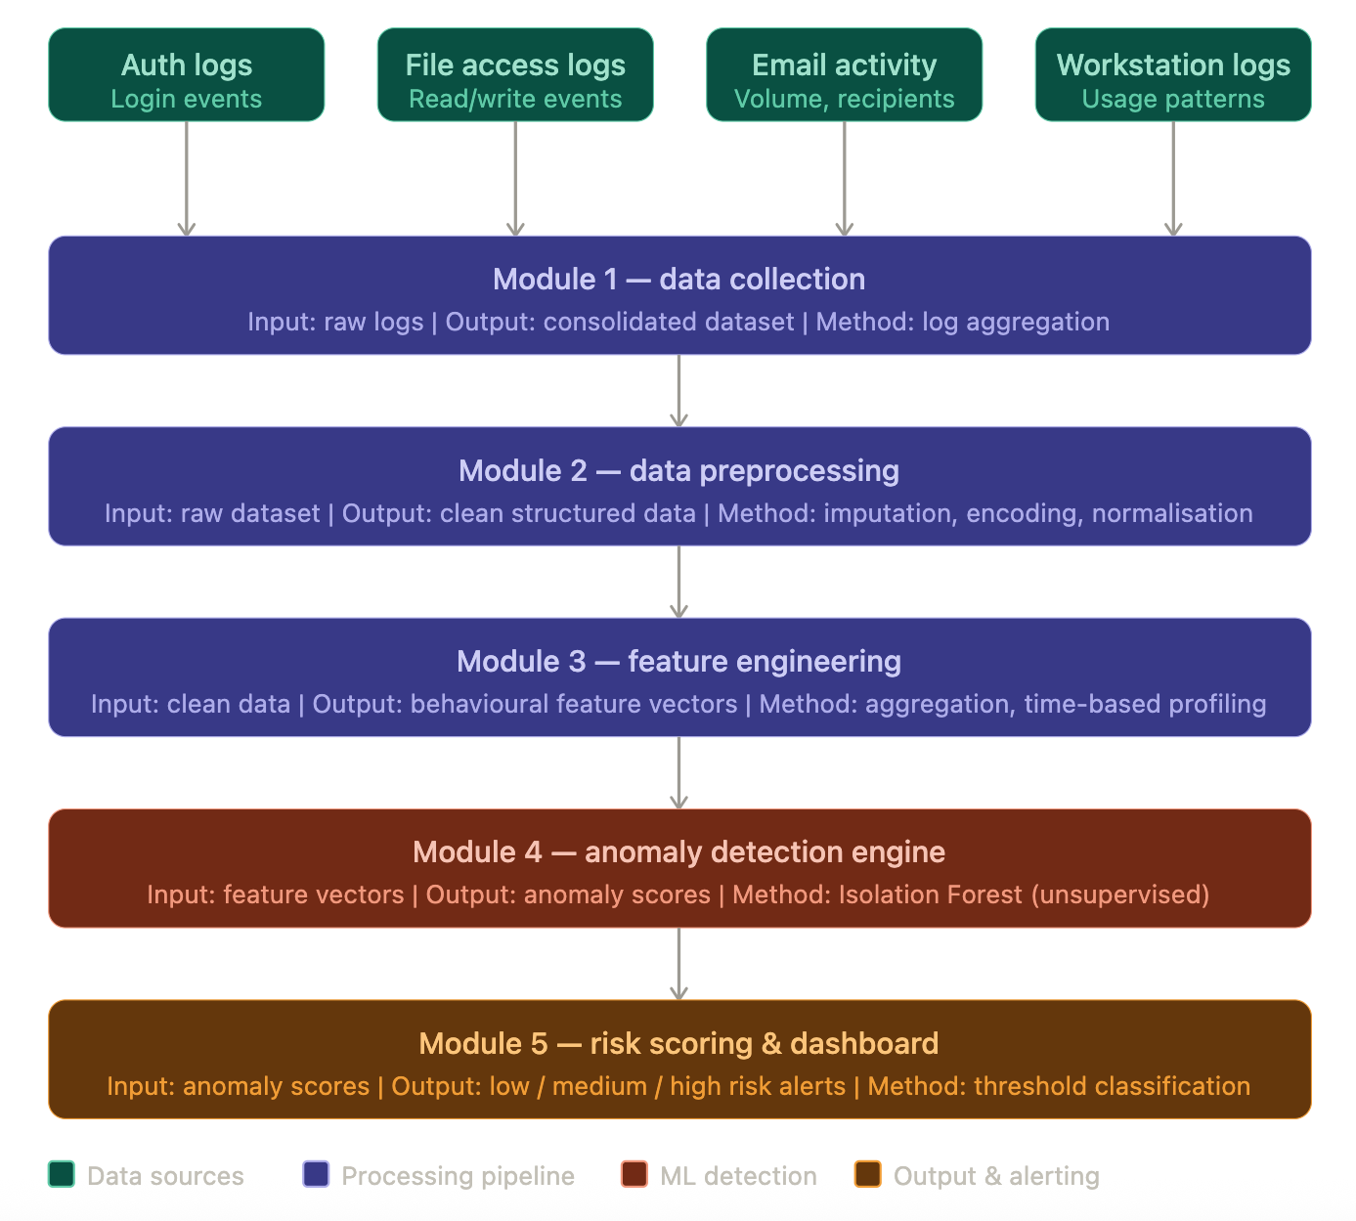
Figure 5: System Architecture Diagram — Machine Learning-Based Insider Threat Detection System
The system uses the CERT 4.2 synthetic insider threat dataset as its primary data source. This dataset provides realistic simulations of user login behavior, file access patterns, email activity, and USB workstation usage across 500 simulated users over a 90-day period, making it suitable for evaluating a behavioral analytics pipeline in a controlled academic environment.

3.2 Methodologies and Tools Used
The system is implemented in Python due to its mature ecosystem for data science and machine learning. The following tools and libraries are used throughout the pipeline:
• Python 3 - Primary programming language
• Pandas - Data manipulation and preprocessing
• NumPy - Numerical computation and feature aggregation
• Scikit-learn - Isolation Forest implementation and feature scaling
• Matplotlib and Seaborn - Data visualization and dashboard generation
• Git and GitHub - Version control and project collaboration
• Google Colab - Cloud-based development and execution environment

The system design was guided by a clear separation between functional requirements, which specify the behavioral capabilities each module must deliver, and non-functional requirements, which govern performance, usability, and maintainability constraints across the pipeline (Letaw, 2024). The Isolation Forest algorithm was selected as the core detection mechanism due to its proven effectiveness in identifying anomalies in high-dimensional, unlabeled datasets. The algorithm operates by recursively and randomly partitioning the feature space. Anomalies are identified as observations that require fewer random splits to isolate relative to normal observations, reflecting the intuition that anomalous data points occupy sparse, low-density regions of the feature space and are therefore easier to isolate than observations embedded in the dense regions characteristic of normal behavior (Liu et al., 2008).

3.3 Data Flow and System Components
The five pipeline modules communicate through a sequential, structured data flow. Each module writes its output to a persistent intermediate storage location accessible to the downstream module, ensuring loose coupling between pipeline stages and enabling individual modules to be tested or replaced independently.
The Data Collection Module ingests raw log files from four CERT 4.2 data sources: authentication records, file access logs, email server data, and USB workstation activity records. These source files are merged using a common user ID and timestamp key, producing a single consolidated Pandas DataFrame that serves as the input to the preprocessing stage.
The Data Preprocessing Module processes the consolidated DataFrame to produce a clean, normalized, and consistently encoded dataset. Missing numerical values are imputed using median substitution to avoid introducing bias from mean imputation in the presence of skewed distributions. Categorical fields are label-encoded to numerical representations compatible with downstream machine learning operations. All timestamps are standardized to ISO 8601 format to ensure consistent temporal comparisons, and numerical features are z-score normalized to prevent features with large absolute ranges from dominating the anomaly detection model.
The Feature Engineering Module transforms the preprocessed event-level data into a user-level behavioral feature matrix. Rather than operating on individual log events, this module aggregates activity across the full 90-day observation period to produce a single feature vector per user. This vector captures 17 behavioral indicators spanning login timing and frequency, file access patterns, email communication behavior, and USB device usage, as summarized in Table 1.

Feature Category | Feature Name | Description
Login Behavior | total_logins | Total login events per user across the observation window
Login Behavior | off_hours_login_rate | Proportion of logins occurring outside standard business hours
Login Behavior | weekend_login_rate | Proportion of logins occurring on weekends
Login Behavior | unique_pcs_used | Number of distinct machines accessed by the user
Login Behavior | avg_session_duration | Average duration of active login sessions in minutes
File Access | total_file_events | Total file access events per user
File Access | sensitive_file_rate | Proportion of file accesses involving sensitive file types
File Access | file_deletions | Total file deletion events per user
File Access | off_hours_file_rate | Proportion of file access events outside business hours
Email Behavior | total_emails | Total emails sent per user
Email Behavior | external_email_rate | Proportion of emails sent to external recipients
Email Behavior | attachment_rate | Proportion of outgoing emails containing attachments
Email Behavior | large_attachment_rate | Proportion of attachments exceeding a defined size threshold
Device Usage | usb_connections | Total USB device connection events
Device Usage | off_hours_usb_rate | Proportion of USB connections outside business hours
Device Usage | weekend_usb_rate | Proportion of USB connections occurring on weekends
Composite | activity_diversity_score | Composite measure of the breadth of system activity types used
Table 1: Summary of Engineered Behavioural Features

The Anomaly Detection Engine receives the behavioral feature matrix and applies the Isolation Forest algorithm with 200 estimators and a contamination parameter of 0.05, reflecting the assumption that approximately 5% of users may exhibit anomalous behavior. The model assigns a raw anomaly score to each user, which is then linearly rescaled to a 0 to 100 range to produce normalized risk scores interpretable without specialist machine learning knowledge.
The Risk Scoring Module applies threshold-based classification to the normalized scores, categorizing each user as Low Risk (score below 40), Medium Risk (score between 40 and 70), or High Risk (score above 70). Results are stored in a structured output file and simultaneously passed to the visualization layer, which generates four chart outputs used to validate and communicate the model's findings.

3.4 Design Diagrams
The system architecture follows a linear pipeline design pattern in which data flows sequentially through each module. The data flow begins with raw, multi-source log files and terminates with a risk-classified user report accessible to security analysts. Each module writes its output to a persistent intermediate storage location accessible by the downstream module, ensuring loose coupling between pipeline stages and enabling independent testing and maintenance of each component.
The modular design also supports future extensibility. Walker (2022) highlights that modular pipeline architectures improve long-term maintainability because components can be updated or replaced without cascading changes across the broader system. For example, the anomaly detection engine could be replaced with a deep learning autoencoder without requiring modifications to the upstream feature engineering or downstream risk scoring logic. Similarly, the data collection module could be extended to incorporate real-time streaming data by substituting the batch file ingestion process with a streaming connector without altering downstream pipeline stages.
CHAPTER 4: RESULTS

4.1 Implementation Overview
The system was implemented as a five-stage Python pipeline executed in Google Colab using the CERT 4.2 synthetic insider threat dataset. The pipeline successfully processed data from 500 simulated users across 90 days of activity, generating a total of approximately 600,000 events across logon, file access, email, and USB device data sources. All five modules executed without errors and produced outputs consistent with the expected behavioral patterns of the simulated dataset.
The feature engineering module successfully extracted 17 behavioral indicators per user, producing a complete feature matrix of 500 rows by 17 columns. The Isolation Forest model was trained with 200 estimators and a contamination parameter of 0.05, flagging approximately 25 users as anomalous. Risk scores were normalized to the 0 to 100 scale and classified into Low, Medium, and High risk tiers using the thresholds defined in Table 2.

4.2 Output and Screenshots

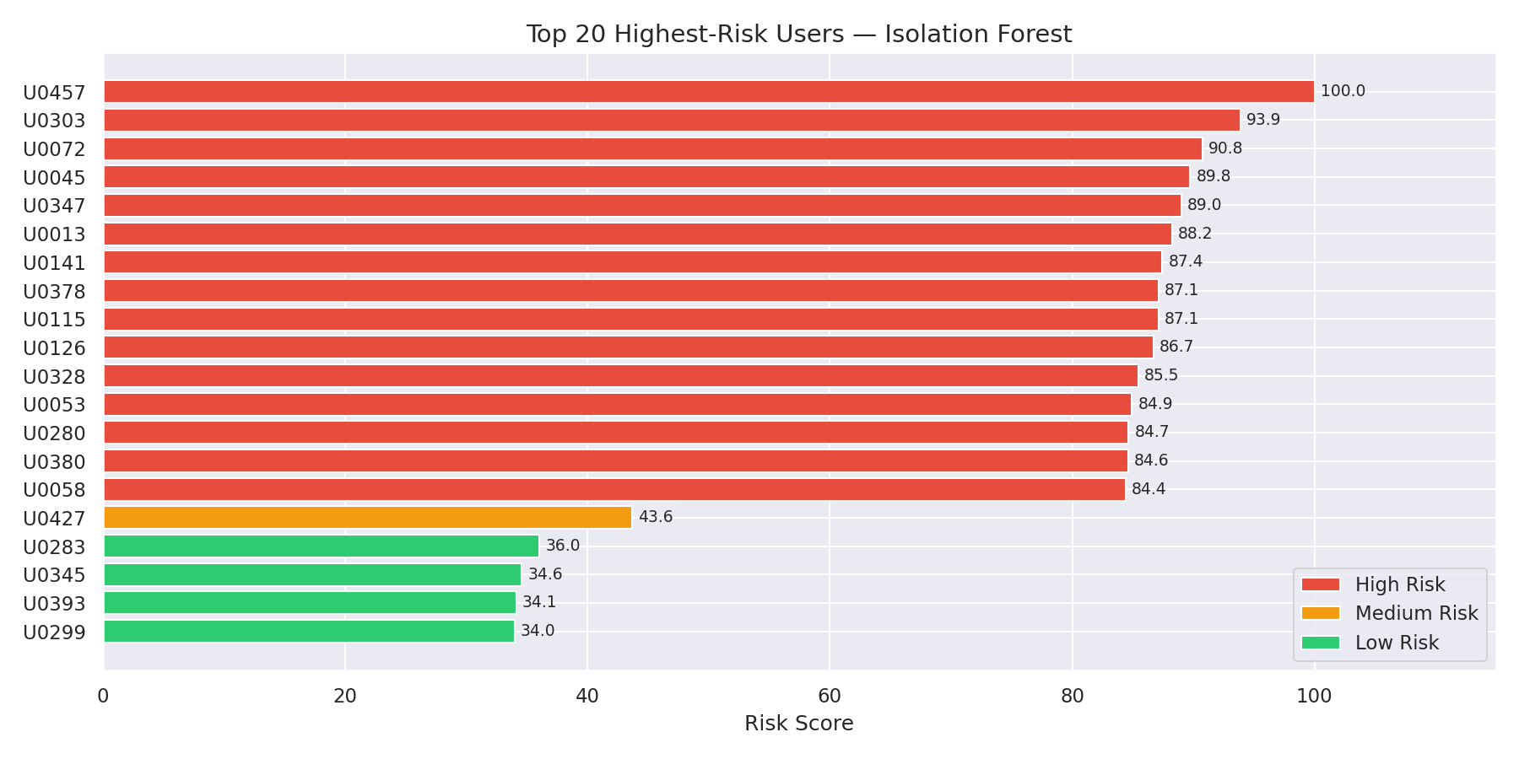
Figure 1: Top 20 Highest-Risk Users — Isolation Forest Risk Scores

Figure 1 presents the 20 users with the highest normalized risk scores as produced by the Isolation Forest model. The majority of flagged users fall into the High Risk category with scores above 70, with user U0457 receiving the maximum score of 100.0. The concentration of scores at the high end of the scale for the top 15 users suggests that these individuals exhibit behavioral patterns that are significantly and consistently distinct from the broader user population, rather than representing marginal boundary cases.
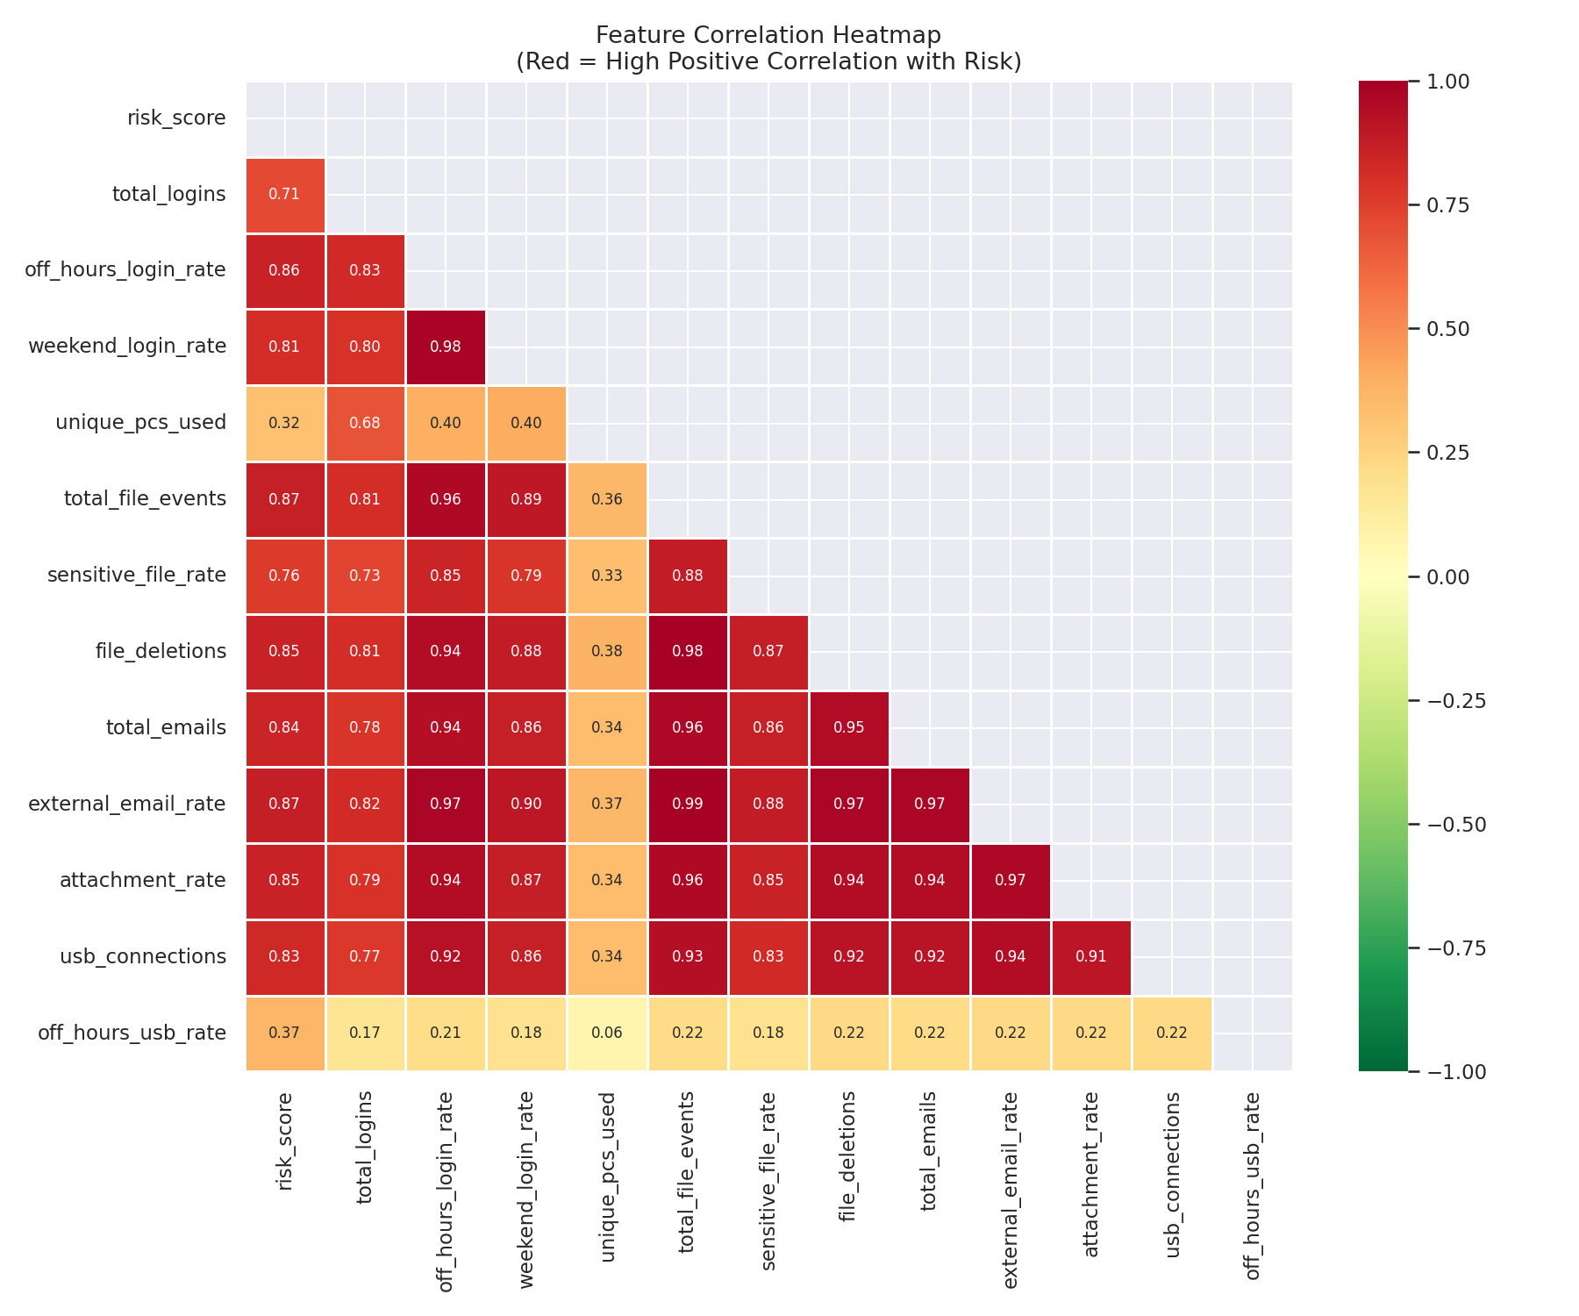
Figure 2: Feature Correlation Heatmap — Correlation of Behavioural Features with Risk Score
Figure 2 displays a correlation heatmap showing the pairwise relationships between all engineered behavioral features and the final normalized risk score. Several features demonstrate strong positive correlations with the risk score. Off-hours login rate (r = 0.86), external email rate (r = 0.87), total file events (r = 0.87), and file deletions (r = 0.85) emerge as the most predictive indicators. These findings align with established behavioral signatures of insider threat activity described in the literature, where off-hours access and data exfiltration via email are commonly documented patterns (Homoliak et al., 2020).

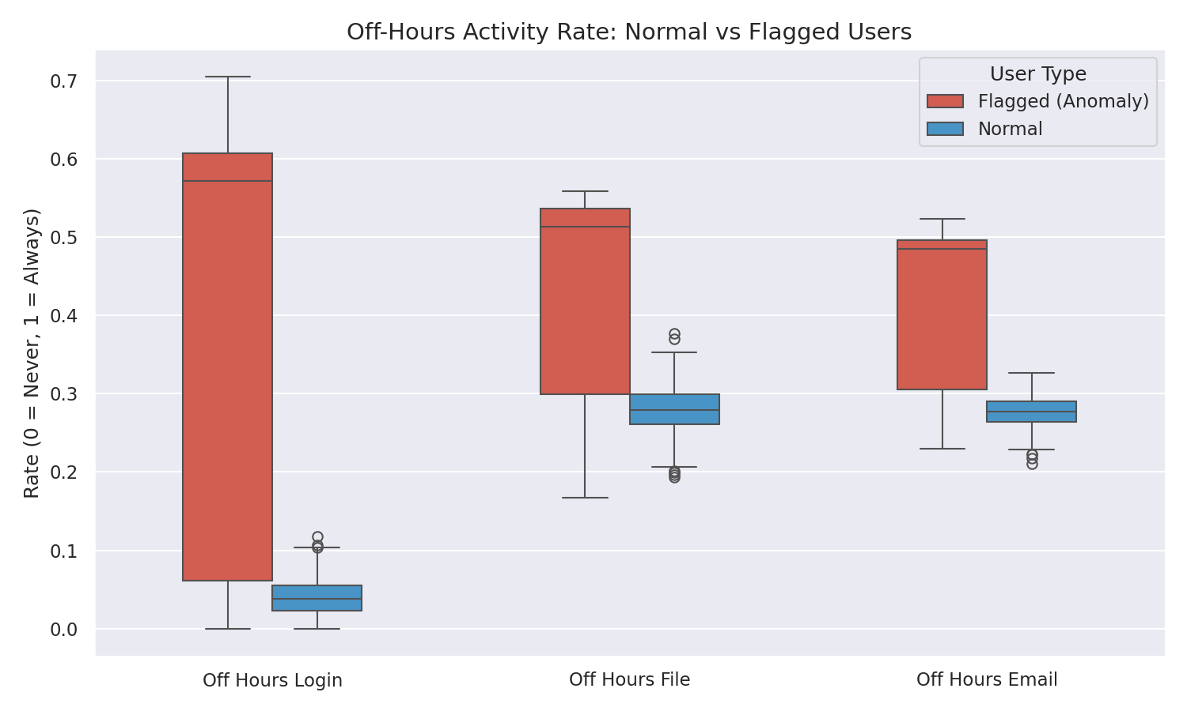
Figure 3: Off-Hours Activity Rate — Normal vs Flagged Users
Figure 3 presents a boxplot comparison of off-hours activity rates between flagged and non-flagged users across login, file access, and email activity dimensions. Flagged users exhibit substantially higher median off-hours rates and greater distributional spread compared to normal users across all three dimensions. This provides strong visual validation that the model correctly identifies users with deviant temporal activity patterns and that the behavioral separation is robust rather than driven by outliers.
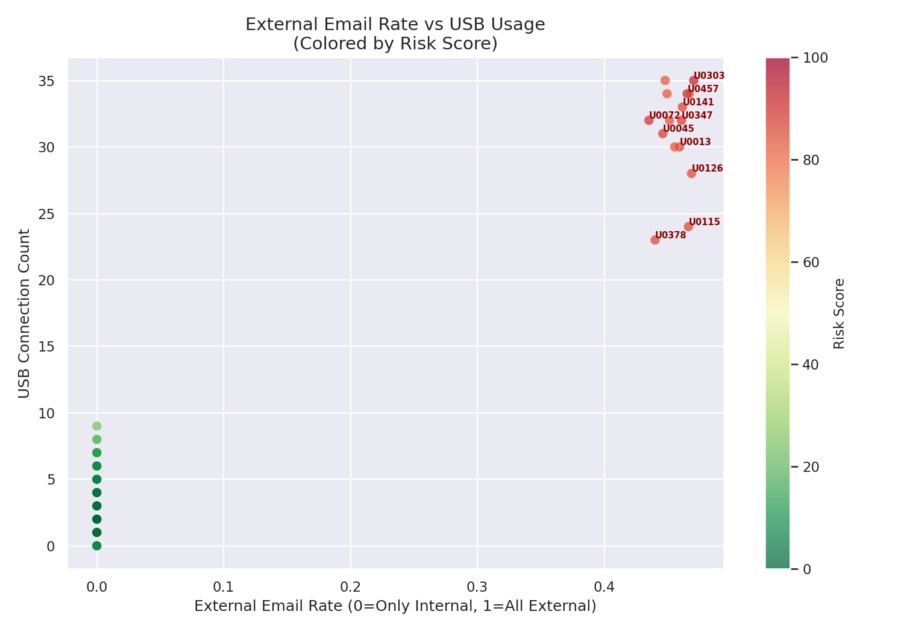
Figure 4: External Email Rate vs USB Connection Count — Coloured by Risk Score Showing Highest Risk
Figure 4 presents a scatter plot mapping each user's external email rate against their USB connection count, with points colored by normalized risk score. A clear bimodal distribution is visible in the data: low-risk users are concentrated near the origin with low external email activity and low USB connection counts, while high-risk users cluster in the upper-right quadrant where high external email rates coincide with high USB activity. This pattern is consistent with documented behavioral indicators of data exfiltration, in which insiders simultaneously pursue digital and physical channels for unauthorized data transfer (Sultana et al., 2021).

4.3 Evaluation Metrics
Because the detection model is unsupervised, traditional binary classification metrics such as accuracy, precision, recall, and F1 score are not directly applicable without ground truth labels for all users. Evaluation is therefore based on three complementary assessment dimensions: anomaly score distributional consistency, behavioral feature validation, and pattern interpretability.
The distribution of normalized anomaly scores demonstrates clear separation between the bulk of the user population, which clusters at low score values, and the flagged anomalous users, who occupy the high end of the score range. This distributional separation confirms that the Isolation Forest model is effectively discriminating between behavioral profiles rather than producing uniformly distributed or random scores.
Feature correlation analysis confirms that the engineered behavioral features capture meaningful predictive signals. The features most strongly correlated with the risk score, including off-hours access rates, external email activity, and file deletion frequency, align with the behavioral indicators identified in the insider threat literature as characteristic of malicious insiders engaged in data exfiltration or sabotage.
Visualization analysis further validates the model by demonstrating that flagged users exhibit behavioral profiles that are consistently and meaningfully distinct from non-flagged users across multiple independent dimensions. The convergence of evidence across the heatmap, boxplot, and scatter plot outputs supports the conclusion that the model is detecting genuine behavioral anomalies rather than statistical noise.

Risk Level | Score Range | Recommended Action
Low Risk | 0 — 39 | Monitor passively; no immediate action required
Medium Risk | 40 — 69 | Review activity logs; flag for further monitoring and periodic reassessment
High Risk | 70 — 100 | Immediate analyst review; escalate if anomalous behavior persists or intensifies
Table 2: Risk Level Classification Thresholds

CHAPTER 5: DISCUSSION

5.1 Interpretation of Results
The results of this project demonstrate that the Isolation Forest algorithm, combined with multi-source behavioral feature engineering, is capable of effectively identifying users with statistically deviant activity profiles within the CERT 4.2 dataset. The strong correlations observed between off-hours activity, external email behavior, USB usage frequency, and the final normalized risk score are consistent with the behavioral signatures of insider threat activity documented in the existing literature. The combination of high external email rates and high USB connection counts observed in the highest-ranked users aligns closely with the data exfiltration patterns documented by Gavai et al. (2015) and Sultana et al. (2021), both of whom identify simultaneous digital and physical data transfer channels as a characteristic indicator of malicious insider activity.
The graded risk scoring approach adopted in this system represents a meaningful improvement over binary anomaly classification. By presenting analysts with a continuous risk score normalized to a 0 to 100 scale and further classified into Low, Medium, and High tiers, the system supports proportionate investigation responses and enables analysts to prioritize their review of flagged cases by severity. This design directly addresses the interpretability gap identified in the research gap analysis, where many prototype systems produce technically accurate anomaly outputs that lack the communicative clarity required for operational use.
The feature correlation analysis provides an additional validation layer that goes beyond anomaly score inspection. By confirming that the features most strongly associated with the risk score align with domain-established insider threat indicators, the correlation heatmap provides behavioral evidence that the model's classifications are grounded in meaningful user activity patterns rather than spurious statistical artifacts.

5.2 Limitations
Although the proposed system demonstrates the potential of machine learning for insider threat detection, several limitations must be acknowledged. The most significant limitation is the use of synthetic data. While the CERT 4.2 dataset provides realistic behavioral simulations that have been validated in the research literature, it does not fully capture the behavioral complexity, contextual noise, or organizational heterogeneity present in real deployment environments. Model performance on live organizational data may differ substantially from the results observed in this controlled evaluation.
A second limitation is the static nature of the behavioral feature aggregation. By computing user-level features over the full 90-day observation window, the system treats each user's behavior as a single static profile. This approach cannot detect gradual behavioral drift, in which a user's activity shifts incrementally toward anomalous patterns over time in a manner that is individually subtle but cumulatively significant. Tuor et al. (2017) specifically identify this as a meaningful limitation of static aggregation approaches and propose sequential modeling as a solution.
The unsupervised nature of the Isolation Forest algorithm also means that the system cannot directly determine whether a flagged anomaly reflects malicious intent, unusual but legitimate behavior, or a data quality artifact. Human analyst review is required for all High Risk cases, which may create workload challenges in organizations with large user populations or limited security analyst capacity.
Finally, the system operates in batch processing mode on historical data and does not support real-time monitoring. Organizations that require immediate detection and response capability would need to substantially redesign the data ingestion and processing layers to support streaming data pipelines, which is beyond the scope of this prototype implementation.

5.3 Ethical Considerations
Insider threat detection systems introduce significant ethical considerations because they involve systematic monitoring of individual user behavior within an organization. Authentication records, file access logs, email metadata, and device usage data collectively constitute a detailed behavioral profile of each employee's working patterns. Monitoring systems of this kind may be perceived as intrusive or as a violation of reasonable privacy expectations if not properly governed, disclosed, and administered.
Transparency is a foundational ethical requirement for any behavioral monitoring system deployed in a workplace context. Employees should be informed of what behavioral data is collected, how it is analyzed, and how results are used in organizational security decisions. Absent such transparency, monitoring systems risk undermining organizational trust and may expose the implementing organization to legal liability in jurisdictions with strong employee privacy protections.
The risk of false positives is a significant ethical concern in anomaly detection systems. A user whose behavior is flagged as High Risk due to legitimate but unusual work patterns, such as a researcher who routinely works unusual hours or regularly transfers large files as part of their role, may be subjected to unwarranted scrutiny or disciplinary consequences. To mitigate this risk, the system is explicitly designed to produce risk classifications rather than definitive determinations of malicious intent, and all flagged cases are presented as requiring human analyst review rather than automatic action.
The use of the CERT 4.2 synthetic dataset substantially reduces the ethical risks associated with this project by ensuring that no real user identities, genuine behavioral records, or sensitive personal information are processed or exposed at any stage of the implementation (CERT Division, 2023). This design choice reflects a deliberate ethical commitment to developing detection capabilities in a manner that respects individual privacy.

5.4 Recommendations for Future Research
Several directions for future research and development emerge from the limitations and findings of this project. Letaw (2024) notes that well-defined requirements serve as the foundation for iterative system improvement, providing a baseline against which future enhancements can be assessed. First, the integration of real-time monitoring capabilities would substantially enhance the system's operational value. A streaming data pipeline that continuously ingests user activity records and updates risk scores on a rolling basis would enable immediate detection of emerging threats rather than retrospective identification of past anomalies.
Second, the adoption of temporal modeling approaches, such as Long Short-Term Memory networks or other recurrent neural network architectures, would address the current system's inability to detect gradual behavioral drift. Sequential models that evaluate user behavior in time-ordered windows rather than static aggregates are better positioned to identify the incremental behavioral changes that often precede confirmed insider incidents.
Third, adaptive learning techniques that periodically retrain the behavioral baseline model with updated user activity data would address the risk of model staleness as organizational work patterns evolve over time. A system that periodically updates its understanding of normal behavior is substantially more resilient to the behavioral evolution of its user population than a static model trained once on historical data.
A formal evaluation framework using the labeled ground truth provided for a subset of known malicious users in the CERT dataset would enable the computation of precision and recall metrics and provide a quantitative performance baseline for comparing the Isolation Forest approach against alternative detection algorithms.
CHAPTER 6: DOCUMENTATION OF PROGRESS AND MILESTONES

6.1 Milestones Achieved
Unit 1 - Literature Review and Problem Definition: The initial unit established the theoretical and contextual foundation for the project. A comprehensive literature review was completed, surveying peer-reviewed research on machine learning-based insider threat detection, unsupervised anomaly detection methods, and behavioral analytics pipelines. The problem statement was formalized around the core challenge of detecting insider threats without labeled training data. A key dataset decision was also made at this stage: the original project plan had intended to use the full CERT dataset directly from its source, but access and storage limitations made this impractical. The CERT 4.2 synthetic dataset, which is publicly documented and widely used in academic research, was adopted as a suitable and ethically sound alternative that still enabled rigorous evaluation of the detection pipeline.
Unit 2 - Dataset Acquisition and Preprocessing: The CERT 4.2 dataset was acquired and loaded into Google Colab, which was selected as the development environment for its accessibility, zero-configuration setup, and ease of iterative testing across sessions. The data preprocessing pipeline was developed and validated, encompassing missing value imputation, timestamp standardization, label encoding of categorical variables, and z-score normalization of numerical fields. The consolidated multi-source DataFrame was verified to confirm correct merging across all four data source files.
Unit 3 -System Architecture, Feature Engineering, and Model Implementation: The full five-stage system architecture was designed and documented, following the systems engineering principle that each component should have clearly defined functional and performance specifications before implementation begins (Summers, 2020). The feature engineering module was developed to extract 17 behavioral indicators per user from the preprocessed dataset. The Isolation Forest model was trained and evaluated, producing normalized risk scores for all 500 users. Four visualization outputs were generated, confirming that the model's classifications align with documented insider threat behavioral patterns. The system architecture diagram was produced using Draw.io and is included in the project repository. Across all three units, the milestones achieved represent substantial and cumulative progress: from problem definition through to a fully operational detection pipeline with interpretable outputs and documented evaluation.

6.2 Challenges Encountered
The development of this project involved several significant challenges that required iterative problem-solving and practical adaptation across all three units of the capstone.
The most persistent challenge was the coding implementation itself. Building a functional multi-stage machine learning pipeline from raw log data through to risk-scored visualizations involved repeated debugging across all five modules. On multiple occasions, the pipeline failed to run end-to-end due to data type mismatches, feature aggregation errors, and inconsistencies in how individual modules formatted their outputs. Each failure required isolating the source of the error, correcting the logic, and revalidating the full pipeline from that point forward. The temporal aggregation design presented a specific sub-challenge: aggregating behavioral features across too short a window produced noisy, day-to-day variability rather than meaningful behavioral signals, while too long a window risked masking short-duration anomalous episodes. The 90-day full-window aggregation adopted in the final implementation represents a pragmatic compromise for the batch processing context of this project.
My second challenge was the development environment. Google Colab was selected for its accessibility, zero-configuration setup, and ease of interactive testing. Working across multiple notebooks introduced a persistent practical limitation: Colab does not retain variables or loaded data between separate sessions. Each time a new session was started, all upstream data had to be reloaded and reprocessed before the current pipeline stage could be run. This created compounding overhead in which a single error late in the pipeline required rerunning all preceding stages from scratch. The solution adopted was to save intermediate module outputs to persistent storage at the end of each stage and reload from those saved files at the start of the next, which reduced but did not fully eliminate the session dependency problem.
A third challenge was determining where to formally address the risk of false positives within the system design. Because the Isolation Forest algorithm is unsupervised, any anomaly it flags may reflect unusual but entirely legitimate user behavior rather than genuine malicious activity. The question of how to communicate this limitation without undermining analyst confidence in the system required deliberate design consideration. The decision was made to address false positives at the risk scoring layer by presenting outputs as graduated risk tiers requiring human review rather than as binary threat determinations, and to address the limitation explicitly in both the ethics and limitations sections of this report.
Version control presented its own practical challenge. The GitHub repository structure evolved considerably across the project as the original development plan changed in response to implementation realities. What began as a more granular multi-notebook structure was progressively consolidated as the pipeline design matured, leaving the commit history reflecting an earlier organizational approach that does not fully correspond to the final submission structure. While the core two-branch workflow of main and development branches was maintained throughout the project (Davies, 2024), the repository does not fully reflect the clean separation that was originally planned. This is acknowledged as a limitation of the version control implementation and an area for improvement in future development work.

CHAPTER 7: CONCLUSION
This project presented the design, implementation, and evaluation of a machine learning-based insider threat detection system that applies behavioral analytics and unsupervised learning to identify anomalous user activity within a simulated organizational environment. The system was structured as a modular five-stage pipeline encompassing data collection, preprocessing, feature engineering, anomaly detection, and risk scoring with visualization, and was evaluated using the CERT 4.2 synthetic insider threat dataset.
The Isolation Forest algorithm was selected as the core detection mechanism due to its demonstrated effectiveness in identifying anomalies in high-dimensional, unlabeled data, its computational efficiency, and its practical suitability for organizational environments where confirmed insider threat incidents are too rare to support supervised learning approaches. The system successfully processed data from 500 simulated users across 90 days of multi-source activity, extracted 17 behavioral features per user, and produced interpretable risk classifications supported by four visualization outputs.
The findings of this project demonstrate that unsupervised machine learning, when combined with domain-informed feature engineering, multi-source data integration, and interpretable risk communication design, can provide an effective and practically deployable foundation for insider threat detection. The behavioral patterns identified by the model, including elevated off-hours activity, high external email rates, and frequent USB connections among high-risk users, are consistent with documented insider threat indicators from the literature, providing both empirical and theoretical validation of the system's detection approach.
While the system is currently limited to prototype implementation on synthetic data with batch processing capabilities, it provides a strong foundation for future development toward real-time deployment, adaptive behavioral modeling, and formal evaluation against labeled ground truth data. The modular architecture ensures that individual components can be extended or replaced as the system evolves without requiring redesign of the broader pipeline. The project was managed throughout using a Git-based version control workflow, with separate main and development branches maintaining a clear distinction between stable deliverables and active work (Davies, 2024). This version control discipline ensures that the complete development history of the system remains auditable and reproducible, supporting both academic accountability and future collaborative development. The project contributes both a functional detection prototype and a set of design principles for interpretable, human-centered insider threat detection that can inform future research and operational system development.
References
Aggarwal, C. C. (2021). Data mining: The textbook. Springer.
CERT Division. (2023). CERT 4.2 synthetic insider threat dataset documentation. Software Engineering Institute, Carnegie Mellon University. https://resources.sei.cmu.edu
Davies, S. (2024). Blueprints: Creating, describing, and implementing designs for larger-scale software projects (Version 2.5). University of Mary Washington. https://open.umn.edu/opentextbooks/textbooks/blueprints-creating-describing-and-implementing-designs-for-larger-scale-software-projects-davis

Gavai, G., Sricharan, K., Gunning, D., Hanley, J., Singhal, M., & Rolleston, R. (2015). Supervised and unsupervised methods to detect insider threat from enterprise social and online activity data. Journal of Wireless Mobile Networks, Ubiquitous Computing, and Dependable Applications, 6(4), 47–63.

Homoliak, I., Toffalini, F., Guarnizo, J., Elovici, Y., & Ochoa, M. (2020). A security reference architecture for insider threat detection. Computers & Security, 89, 101658. https://doi.org/10.1016/j.cose.2019.101658

Kotu, V., & Deshpande, B. (2020). Data science: Concepts and practice (2nd ed.). Morgan Kaufmann.

Letaw, L. (2024). Handbook of software engineering methods [Open textbook]. Oregon State University. https://open.oregonstate.education/setextbook/

Liu, F. T., Ting, K. M., & Zhou, Z. H. (2008). Isolation forest. In Proceedings of the 2008 Eighth IEEE International Conference on Data Mining (pp. 413–422). IEEE. https://doi.org/10.1109/ICDM.2008.17

Patcha, A., & Park, J. M. (2007). An overview of anomaly detection techniques: Existing solutions and latest technological trends. Computer Networks, 51(12), 3448–3470. https://doi.org/10.1016/j.comnet.2007.02.001

Summers, B. L. (2020). Effective methods for software engineering. Auerbach Publishers.

Tuor, A., Kaplan, S., Hutchinson, B., Nichols, N., & Robinson, S. (2017). Deep learning for unsupervised insider threat detection in structured cybersecurity data streams. Workshops at the Thirty-First AAAI Conference on Artificial Intelligence. https://arxiv.org/abs/1710.00811
Walker, V. (2022, March 16). 14 software architecture design patterns to know. Red Hat. https://www.redhat.com/en/blog/14-software-architecture-patterns

Yuan, F., & Wu, Y. (2021). Few-shot intrusion detection via efficient BERT-based log anomaly detection. IEEE Transactions on Information Forensics and Security, 16, 4616–4627. https://doi.org/10.1109/TIFS.2021.3111766
APPENDICES

Appendix A: GitHub Repository
The complete source code, Jupyter notebooks, documentation, and design files for this project are available at the following GitHub repository:
https://github.com/Flipflop-ux/insider-threat-detection-system
The repository is organized into the following directories: src/ contains all Python and Jupyter notebook source files for the five pipeline stages; docs/ contains project documentation and written reports; design/ contains the system architecture diagram in Draw.io format; and results/ contains all exported chart images and visualization outputs. The repository uses a two-branch strategy with a main branch for stable submissions and a development branch for active work.

Appendix B: Functional Requirements Summary
ID | Requirement | Module
FR1 | Collect and consolidate user activity logs from multiple sources | Data Collection
FR2 | Clean and standardize raw log data for consistent pipeline input | Preprocessing
FR3 | Extract behavioral features from preprocessed logs | Feature Engineering
FR4 | Apply unsupervised ML to identify behavioral deviations | Anomaly Detection
FR5 | Convert anomaly scores to interpretable risk classifications | Risk Scoring
FR6 | Display anomaly trends and user risk rankings via visualizations | Visualization
Table 3: Functional Requirements Summary

